Full instructions guide for Employees and Transport systems.
The ultimate guide for transport and employees' systems.

Denis Coleman, Yael Durahly, Ethen Krimer, Tom Gluzman
Welcome to Employees Management system Instructions!!
*Note: instructions are meant for the customer/user.
Summary:
The following employee management system provides a comprehensive framework for managing workforce operations, ensuring efficient and secure access for different roles. The system starts with a Welcome Panel, where users enter their unique ID to gain personalized access, reinforcing security and role-based functionality.
Once inside, regular employees can access the General Employee Panel, which allows them to update their shift availability, view personal information, and manage basic work-related actions. This panel serves as the foundation for all employees, ensuring they can quickly check and update their status within the organization.
For employees with managerial roles, the system offers a specialized Manager Panel, which expands their capabilities to include creating new shifts, adding or removing employees from shifts, promoting employees, and using cancel cards. Managers also have the flexibility to return to the general panel as needed, providing seamless navigation between different levels of authority.
Additionally, the system includes a dedicated HR Panel for those responsible for higher-level organizational control. This panel includes critical actions such as terminating or adding employees, setting global shift hours, and defining required roles for each shift. It allows HR personnel to update role requirements and manage the overall structure of shift assignments, ensuring the workforce remains balanced and efficient.
Together, these panels form a cohesive system that supports the diverse needs of regular employees, managers, and HR personnel, while maintaining detailed historical data for accurate oversight and reporting.

How to Use the System:
When you start the system, you will first decide whether to use the provided mock data or start with a clean database.
Once this choice is made, you will be presented with a welcome panel displaying both the Employee and Transport panels, where you can choose which one to enter or to exit the system.
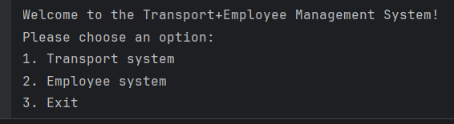
If you choose to enter the Employee Panel, you will be greeted by the Login Panel, where you can either enter your unique employee ID to access your personalized interface or choose to exit, which will return you to the previous welcome panel.
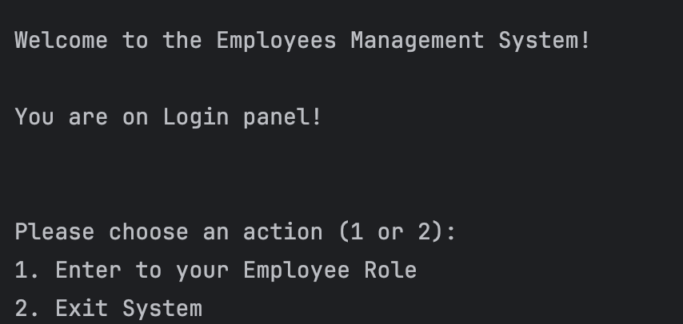
After a successful login, you will gain access to your personalized General Employee Interface, where you can perform the following actions.
1. Set Upcoming Shifts Availability – Allows you to indicate which days and times you are available to work in the upcoming week. This helps shift managers assign you to suitable shifts.
2. Enter to your Managing Role – If you hold a management role (such as Shift Manager or HR), this option takes you to the appropriate management panel, where you can perform role-specific administrative tasks.
3. Show Your Personal Information – Displays your stored personal details, including your name, ID, role(s), and any relevant employment information currently in the system.
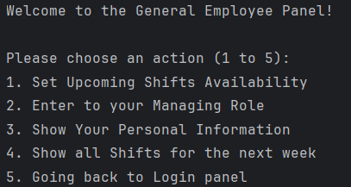
4. Show all Shifts for the next week – Presents a schedule of all upcoming shifts across the system, allowing you to see which shifts are scheduled and prepare accordingly.
5. Going back to Login panel – Logs you out of your session and returns you to the login screen, where another user can enter or the system can be exited.

The HR Panel provides advanced administrative controls for managing the employee database and shift structure.
Upon entering this panel, HR personnel are presented with the following options:
- Terminate Employee from System: The system will prompt the HR lead to enter the necessary employee information to remove them from the database, permanently deleting their records.
- Add New Employee to System: HR can onboard new employees by providing the required personal and role details, adding them to the active employee database.
- Set Default Shift Hours: HR can define the default shift hours for all future shifts.
- Update Required Roles for a Shift: This option allows HR to adjust the required number of employees for a specific role for all the shifts.
- Set All Required Shift Roles: HR can bulk update the staffing requirements for all roles, setting the default number of employees needed for each role across all shifts.
- Update Employee Information: This feature allows HR personnel to modify existing employee records in the system. It includes updating personal details, role assignments, availability schedules and more according to the entered choice.
- Return to General Employee Panel: HR users can exit the HR panel and return to the general employee interface, providing flexibility to switch between administrative and regular functions.
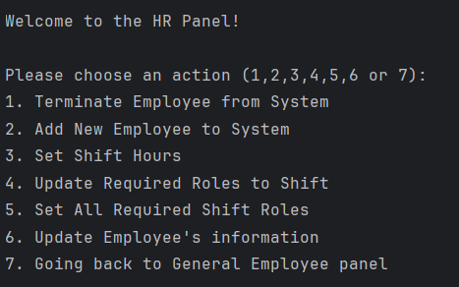

The Shift Manager Panel offers a range of tools for shift management and employee role adjustments.
Upon accessing this panel, managers are presented with the following options:
- Create New Upcoming Shift: The manager can create new upcoming shifts by utilizing the system’s available tools to define shift details and requirements.
- Remove Employee from Upcoming Shift: Allows the manager to remove an employee from a scheduled upcoming shift as needed.
- Add Employee to Upcoming Shift: The manager enters the employee ID, shift ID, and the desired role to assign the employee to that specific role in the shift. The system then verifies the employee’s availability and confirms that the employee holds the requested role before completing the assignment.
- Promote Employee: The manager can assign an additional role to an employee, expanding their responsibilities and permissions within the system.
- Cancel Items from Shopping Cart: Using their manager card, the manager can cancel selected items from the shopping cart when necessary.
- Return to General Employee Panel: Provides the option to exit the Managing Panel and return to the General Employee Panel.
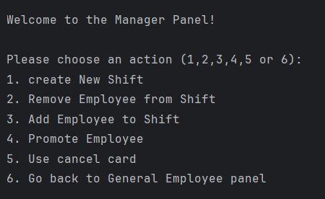

At each step, if the user enters incorrect information, the system will notify him and prompt him to provide the correct details, ensuring a smooth and secure user experience.

Database:
The Employee Management System utilizes two mock databases for efficient data handling.
The Employee Database stores all the essential information about each employee, including their unique ID, name, list of roles, contract, salary, recruitment date, bank information and availability.
The Shift Database is divided into two sections: Past Shifts and Upcoming Shifts. Shifts are automatically transferred to the Past Shifts section once their scheduled time has passed, ensuring accurate tracking of work history.
For demonstration purposes, the mock system includes a sample database with 5 employees and 3 shifts, providing a realistic test environment for the system's functionality.
Employees Database information:
Employee 1
- Employee ID: EMP001
- Name: Alice
- Hourly Wage: 32.5
- Start Date: 15/03/2022
- Roles: Stocker
- Bank Account: Leumi-Hills (Acc: 072543, Branch: 972)
- Contract: 7 hours/day, 14 days/month, 21 shifts/month, 160 hours/month
- Availability:
  - Sunday: Day
  - Monday: Day
  - Tuesday: Day
  - Wednesday: Night
  - Thursday: Unavailable

Employee 2
- Employee ID: EMP002
- Name: Bob
- Hourly Wage: 47.1
- Start Date: 10/01/2023
- Roles: Shift Manager, Stocker
- Bank Account: Hapoalim (Acc: 072923, Branch: 001)
- Contract: 5 hours/day, 10 days/month, 14 shifts/month, 80 hours/month
- Availability:
  - Sunday: Day
  - Monday: Night
  - Tuesday: Night
  - Wednesday: Day
  - Thursday: Day

Employee 3
- Employee ID: EMP003
- Name: Charlie
- Hourly Wage: 120.2
- Start Date: 20/05/2021
- Roles: HR Lead
- Bank Account: Bank-Yahav (Acc: 072577, Branch: 625)
- Contract: 6 hours/day, 12 days/month, 18 shifts/month, 120 hours/month
- Availability:
  - Sunday: Day
  - Monday: Night
  - Tuesday: Day
  - Wednesday: Night
  - Thursday: Day

Employee 4
- Employee ID: EMP004
- Name: David
- Hourly Wage: 35.0
- Start Date: 01/06/2023
- Roles: Stocker
- Bank Account: Bank-Hapoalim (Acc: 072589, Branch: 311)
- Contract: 5 hours/day, 10 days/month, 14 shifts/month, 80 hours/month
- Availability:
  - Sunday: Day
  - Monday: Day
  - Tuesday: Day
  - Wednesday: Day
  - Thursday: Night

Employee 5
- Employee ID: EMP005
- Name: Eve
- Hourly Wage: 33.5
- Start Date: 15/07/2023
- Roles: Stocker, Cleaner
- Bank Account: Discount (Acc: 072111, Branch: 321)
- Contract: 6 hours/day, 12 days/month, 18 shifts/month, 120 hours/month
- Availability:
  - Sunday: Both
  - Monday: Both
  - Tuesday: Both
  - Wednesday: Both
  - Thursday: Both

Employee 6
- Employee ID: EMP006
- Name: Inna
- Hourly Wage: 33.0
- Start Date: 10/07/2024
- Roles: Stocker, Security
- Bank Account: Bank-Yahav (Acc: 0725431, Branch: 972)
- Contract: 6 hours/day, 12 days/month, 18 shifts/month, 120 hours/month
- Availability:
  - Sunday: Both
  - Monday: Both
  - Tuesday: Both
  - Wednesday: Both
  - Thursday: Both

Employee 7
- Employee ID: EMP007
- Name: John
- Hourly Wage: 33.0
- Start Date: 10/07/2024
- Roles: Driver
- Bank Account: Bank-Yahav (Acc: 0725431, Branch: 972)
- Contract: 6 hours/day, 12 days/month, 18 shifts/month, 120 hours/month
- Availability:
  - Sunday: Both
  - Monday: Both
  - Tuesday: Both
  - Wednesday: Both
  - Thursday: Both

Employee 8
- Employee ID: EMP008
- Name: Sam
- Hourly Wage: 33.0
- Start Date: 10/07/2024
- Roles: Driver
- Bank Account: Bank-Yahav (Acc: 0725431, Branch: 972)
- Contract: 6 hours/day, 12 days/month, 18 shifts/month, 120 hours/month
- Availability:
  - Sunday: Both
  - Monday: Both
  - Tuesday: Both
  - Wednesday: Both
  - Thursday: Both

Employee 9
- Employee ID: EMP009
- Name: Jane
- Hourly Wage: 33.0
- Start Date: 10/07/2024
- Roles: Driver
- Bank Account: Bank-Yahav (Acc: 0725431, Branch: 972)
- Contract: 6 hours/day, 12 days/month, 18 shifts/month, 120 hours/month
- Availability:
  - Sunday: Both
  - Monday: Both
  - Tuesday: Both
  - Wednesday: Both
  - Thursday: Both

Shifts Database information:

Shift 1 – past shift
• Shift ID: SHIFT-1
• Shift Type: Day
• Date: 15/05/2021
• Manager: Alice (Employee ID: EMP001)
• Assigned Employees:
Alice (Employee ID: EMP001) - (Role: Stocker)
Bob (Employee ID: EMP002) - (Role: Shift Manager)
- Available Employees:
Inna (Employee ID: EMP006) – (Role: Stocker)

Shift 2 – past shift
• Shift ID: SHIFT-2
• Shift Type: Night
• Date: 12/08/2016
• Manager: Charlie (Employee ID: EMP003)
• Assigned Employees:
Charlie (Employee ID: EMP003) - (Role: HR Lead)
David (Employee ID: EMP004) - (Role: Stocker)
• Available Employees:
Alice (Employee ID: EMP001) - (Role: Stocker)

Shift 3 – past shift
• Shift ID: SHIFT-3
• Shift Type: Day
• Date: 27/05/2025
• Manager: Bob (Employee ID: EMP002)
• Assigned Employees:
Bob (Employee ID: EMP002) - (Role: Shift Manager)
Eve (Employee ID: EMP005) - (Role: Cleaner)
John (Employee ID: EMP007) - (Role: Driver)
• Available Employees:
Charlie (Employee ID: EMP003) - (Role: HR Lead)

Shift 4 - future
• Shift ID: SHIFT-4
• Shift Type: Night
• Date: 26/05/2025
• Manager: Bob (Employee ID: EMP002)
• Assigned Employees:
Bob (Employee ID: EMP002) - (Role: Shift Manager)
David (Employee ID: EMP004) - (Role: Stocker)
Sam (Employee ID: EMP008) - (Role: Driver)
• Available Employees:
John (Employee ID: EMP002) - (Role: Driver)

Shift 5 - future
• Shift ID: SHIFT-5
• Shift Type: Day
• Date: 30/05/2025
• Manager: Bob (Employee ID: EMP002)
• Assigned Employees:
Bob (Employee ID: EMP002) - (Role: Shift Manager)
Alice (Employee ID: EMP001) - (Role: Stocker)
Jane (Employee ID: EMP009) - (Role: Driver)
• Available Employees:
Eve (Employee ID: EMP005) - (Role: Stocker)

For Your Information:
- The system handles HR Lead options permanently, meaning every change he does will be affective from this point forward until he will decide otherwise.
For example setting shift hours will be the ones that he decides for all shifts made from this point onward.
- The system holds Past Shifts up to 7 years, then deletes them.
- The system accommodates fully the User throughout his use of the system, no user will be left out. The system gives explanations about each step and has fail safes.

Welcome to Transport Management system Instructions!!
*Note: instructions are meant for the customer/user.

Login Information
By default, the system does not require a login. If access control is introduced, usernames
and passwords must be documented here.

System Purpose
This system is a command-line Java application designed to help logistics managers
efficiently create, monitor, and manage transports between suppliers and branches using
drivers and trucks. It includes full CRUD (Create, Read, Update, Delete) capabilities for all
major components such as branches, drivers, trucks, and transport routes.

System Launch Instructions
1. Open a terminal window.
2. Navigate to the project directory.
3. Run the system using the following command:
`java -jar release/adss2025_v01.jar`
4. The application starts with a prompt: 'Load mock data? (y/n)'.
- Type 'y' to initialize mock data (sample branches, trucks, drivers, and suppliers).
- Type 'n' to start from scratch.

Main Menu Walkthrough
The main menu includes:
- Manage Transport Areas: Connect suppliers and branches into transport zones.
- Manage Transports: Create, view, and delete logistics operations.
- Manage Trucks: Maintain vehicle records.
- Manage Drivers: Add or update drivers and their license types.
- Manage Branches: Track branch locations and contact info.
- Exit: Close the program safely.
- Load Temporary Mock Data: Reinitialize demo data at any point.

Creating a Transport
To create a transport:
1. Choose 'Manage Transports' from the main menu.
2. Select 'Create transport'.
3. Enter a planned date and time for delivery.
4. Choose a source branch.
5. Select items from inventory to include in the transport.
6. System will attempt to find routes and available trucks/drivers.
7. You will be prompted to pick from valid trucks and drivers.
8. Upon success, a full transport is created and listed.

Drivers and Trucks
Each driver must be assigned a license type (B, C, C1, etc.).
Each truck requires a specific license type to operate.
The system only allows pairing a driver with a truck they are qualified to drive.

Mock Data Description
The mock data includes:
Branches
Three branches are added:
- Branch1 – Address: "Address1", Phone: "+972 5412311"
- Branch2 – Address: "Address2", Phone: "+972 5488899"
- Branch3 – Address: "Address3", Phone: "+972 5412988"

Drivers
Three drivers with different license types:
- John Doe – ID: "123456789", Phone: "+972 5412311", License: "C"
- Sam Wilson – ID: "987654321", Phone: "+972 5488899", License: "B"
- Jane Smith – ID: "456789123", Phone: "+972 5412988", License: "C1"

Trucks
Three trucks with different capacities and required license types:
- Truck 5498875 – Weight: 3500kg, Max load: 5000kg, License: "C1", Manufacturer: "Toyota"
- Truck 5491176 – Weight: 1000kg, Max load: 3000kg, License: "C", Manufacturer: "Ford"
- Truck 5491177 – Weight: 4500kg, Max load: 7000kg, License: "C1", Manufacturer: "Mercedes"

Suppliers
Three suppliers located at different addresses:
- Supplier1 – Address: "Address1", Phone: "+972 77788855"
- Supplier2 – Address: "Address2", Phone: "+972 77788856"
- Supplier3 – Address: "Address3", Phone: "+972 77788857"

Transport Areas
Two transport areas are created, each associating existing branches and suppliers:
- Area1 – Includes all created branches and suppliers
- Area2 – Includes a subset (first two) of branches and suppliers

Transport Planning
- A set of stock items is retrieved based on a mock search (with placeholder query "").
- A transport route is planned for the next day, using the selected stock items.
- The system finds an available truck and a driver with a matching license for the planned date.
- Finally, a transport is created linking the planned time, selected truck and driver, and the created transport routes.

Error Handling and Tips
The program uses Helper methods to validate user input. If an entry is invalid, the user is
prompted again.
- Do not leave inputs blank.
- Follow format for dates and numbers.
- Ensure there are available drivers and trucks for the given transport date.
Extending the System
You can extend functionality by:
- Adding transport history and tracking.
- Introducing login/authentication features.
- Adding GUI components for ease of use

--------------------------------------------------------------------------------------------------------------------

External libraries:
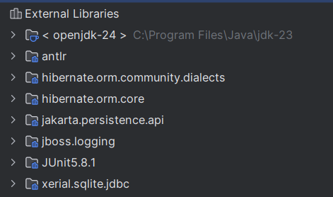
antlr – Used for parsing and analyzing structured text (like SQL or code), used by Hibernate for interpreting query languages.
hibernate.orm.community.dialects – Contains additional SQL dialects for supporting various databases in Hibernate.
hibernate.orm.core – The main Hibernate ORM framework, enabling mapping Java classes to database tables and managing persistent data.
jakarta.persistence.api – Provides the standard JPA interfaces (like Entity, EntityManager, etc.) which Hibernate implements.
jboss.logging – A logging framework used by Hibernate and related libraries for consistent, configurable logging.
JUnit 5.8.1 – A testing framework for writing and running unit tests in Java.
xerial.sqlite.jdbc – A JDBC driver that allows Java applications to connect to SQLite databases.

Good Luck!

